# Lab: Objects and DOM

Problems for in-class lab for the ["JavaScript Essentials" course @ SoftUni](https://softuni.bg/courses/js-essentials). Submit your solutions in the SoftUni judge system at <https://judge.softuni.bg/Contests/1425/Lab-Objects-and-DOM>

## Towns to JSON

You’re tasked to create and print a JSON from a text table. You will receive input as an array of strings, where each string represents a row of a table, with values on the row encompassed by pipes **"|"** and optionally spaces. The table will consist of exactly 3 columns **“Town”**, **“Latitude”** and **“Longitude”**. The **latitude** and **longitude** columns will always contain **valid numbers**. Check the examples to get a better understanding of your task.

The **input** comes as an array of strings - the first string contains the table’s headings, each next string is a row from the table.

The **output** should be printed on the console **stringified** - for each entry row in the input print the object representing it.

### Examples

|  |
| --- |
| **Input** |
| ['| Town | Latitude | Longitude |',  '| Sofia | 42.696552 | 23.32601 |',  '| Beijing | 39.913818 | 116.363625 |']; |
| **Output** |
| [{"Town":"Sofia","Latitude":42.69,"Longitude":23.32}, {"Town":"Beijing","Latitude":39.91,"Longitude":116.36}] |
| Input |
| ['| Town | Latitude | Longitude |',  '| Veliko Turnovo | 43.0757 | 25.6172 |',  '| Monatevideo | 34.50 | 56.11 |'] |
| **Output** |
| [{"Town":"Veliko Turnovo","Latitude":43.0757,"Longitude":25.6172}, {"Town":"Monatevideo","Latitude":34.5,"Longitude":56.11}] |

## Sum by Town

You’re tasked with calculating the total sum of income for several Towns. You will receive an array of strings representing towns and their incomes, every **even** index will be a **town** and every **odd** index will be an **income** belonging to that town. Create an object that will hold all the **towns as keys** and their **total income** (the sum of their incomes) **as values** to those keys and print it as a JSON.

The **input** comes as an array of strings - each even index is the name of a town and each odd index is an income belonging to that town.

The **output** should be printed on the console - JSON representation of the object containing all towns and their total incomes.

### Examples

|  |  |
| --- | --- |
| **Input** | **Output** |
| Sofia  20  Varna  3  Sofia  5  Varna  4 | {"Sofia":25,"Varna":7} |
| Sofia  20  Varna  3  sofia  5  varna  4 | {"Sofia":20,"Varna":3,"sofia":5,"varna":4} |

## Count Words in a Text

You are tasked to count the number of words in a text using an object as an associative array, any combination of letters, digits and _ (underscore) should be counted as a word. The words should be stored in the object as properties - the **key** being the **word** and the **value** being the **amount of times the word is contained** **in the text**.

The **input** comes as an array of strings containing one entry - the text whose words should be counted. The text may consist of more than one sentence.

The **output** should be printed on the console - the JSON representation of the object containing the words.

### Examples

|  |
| --- |
| **Input** |
| Far too slow, you're far too slow. |
| **Output** |
| {"Far":1,"too":2,"slow":2,"you":1,"re":1,"far":1} |
| Input |
| JS devs use Node.js for server-side JS.-- JS for devs |
| **Output** |
| {"JS":3,"devs":2,"use":1,"Node":1,"js":1,"for":2,"server":1,"side":1} |

## Populations in Towns

You have been tasked to create a register for different **towns** and their **population**.

The **input** comes as array of strings. Each element will contain data for a town and its population in the following format:

“{townName} <-> {townPopulation}”

If you receive the same town twice, **you should add** the **given population** to the **current one**.

As **output**, you must print all the towns, and their population.

### Examples

|  |  |
| --- | --- |
| **Input** | **Output** |
| Sofia <-> 1200000  Montana <-> 20000  New York <-> 10000000  Washington <-> 2345000  Las Vegas <-> 1000000 | Sofia : 1200000  Montana : 20000  New York : 10000000  Washington : 2345000  Las Vegas : 1000000 |

|  |  |
| --- | --- |
| **Input** | **Output** |
| Istanbul <-> 100000  Honk Kong <-> 2100004  Jerusalem <-> 2352344  Mexico City <-> 23401925  Istanbul <-> 1000 | Istanbul : 101000  Honk Kong : 2100004  Jerusalem : 2352344  Mexico City : 23401925 |

## Articles List

In this problem, you should create a JS functionality which creates articles and appends them into some article section.

The programs in this language are called **scripts**. They can be written right in the HTML and **executed** **automatically** as the page loads.

Scripts are provided and executed as a **plain text**. They don't need a special preparation or a compilation to run.

In this aspect, JavaScript is very **different** from another language called Java.

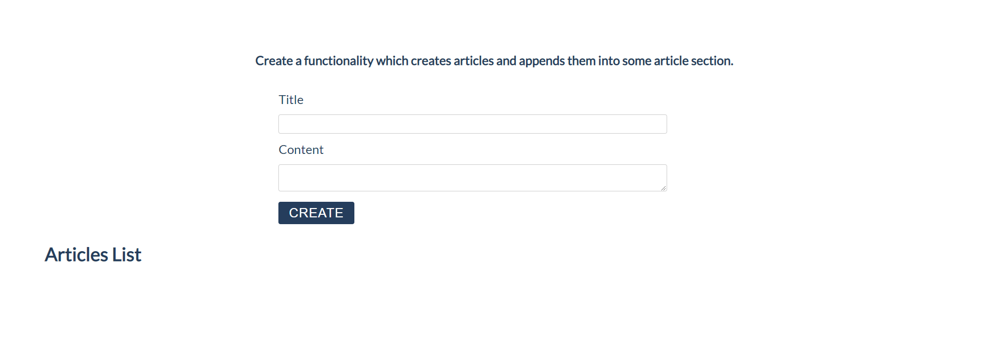

### Constraints:

* **Title value** from the **title input** should be a **heading 3 element <h3>**
* **Content text** from the **textarea element** should be a **paragraph <p>**
* Both new created elements (**h3** and **p**) should be appended to a new **article element <article>**
* **The current article element** should be **appended** to the section which has an id articles (**#articles**)
* You should create new **article element** only if **title** and **content are not empty**
* After the button is pressed you must **clear** the **title value** and **text value**

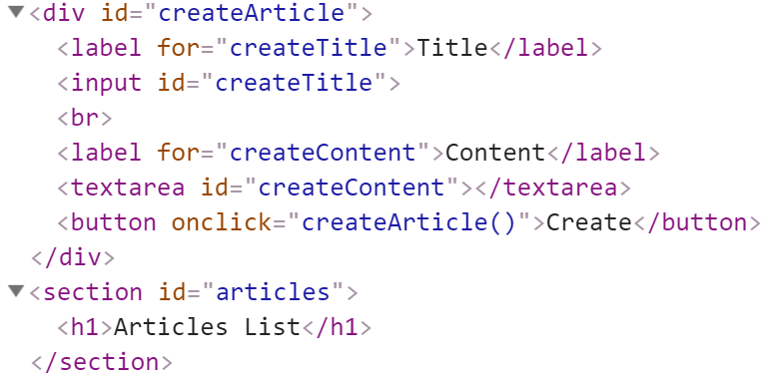

### Input:

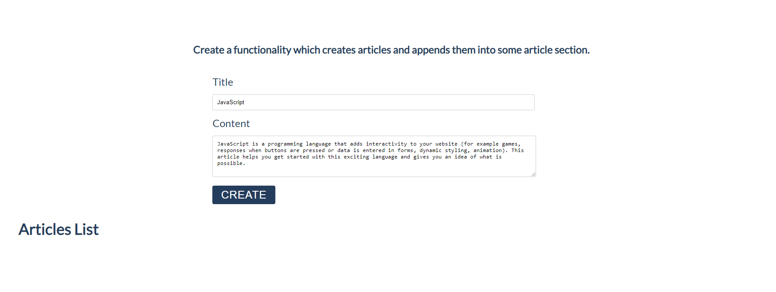

### Output:

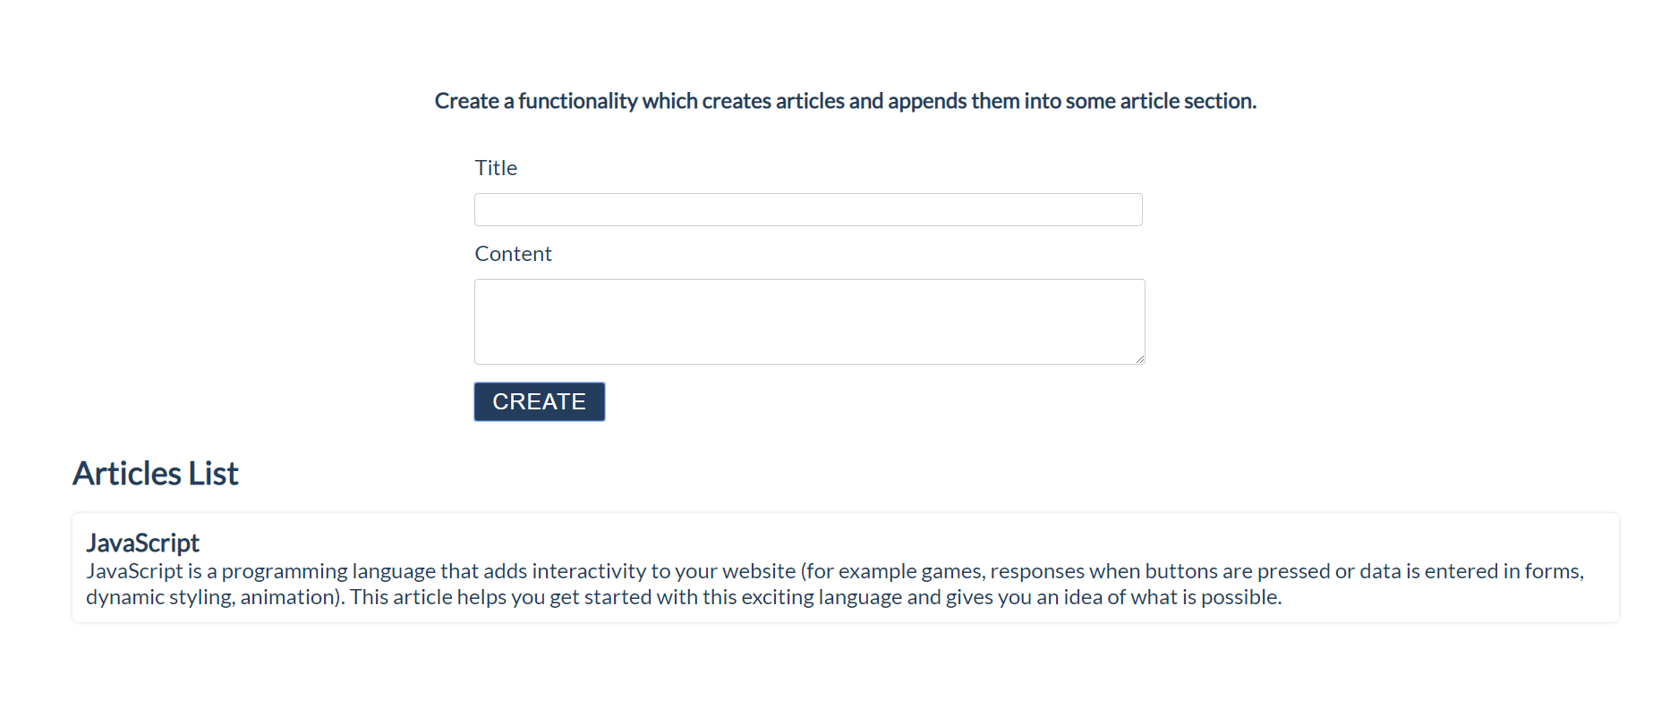

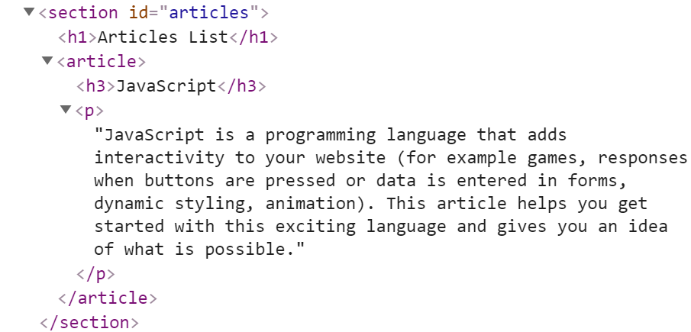

## Format the Text

In this problem, you should **create a JS functionality** which **formats the given text into paragraphs.**

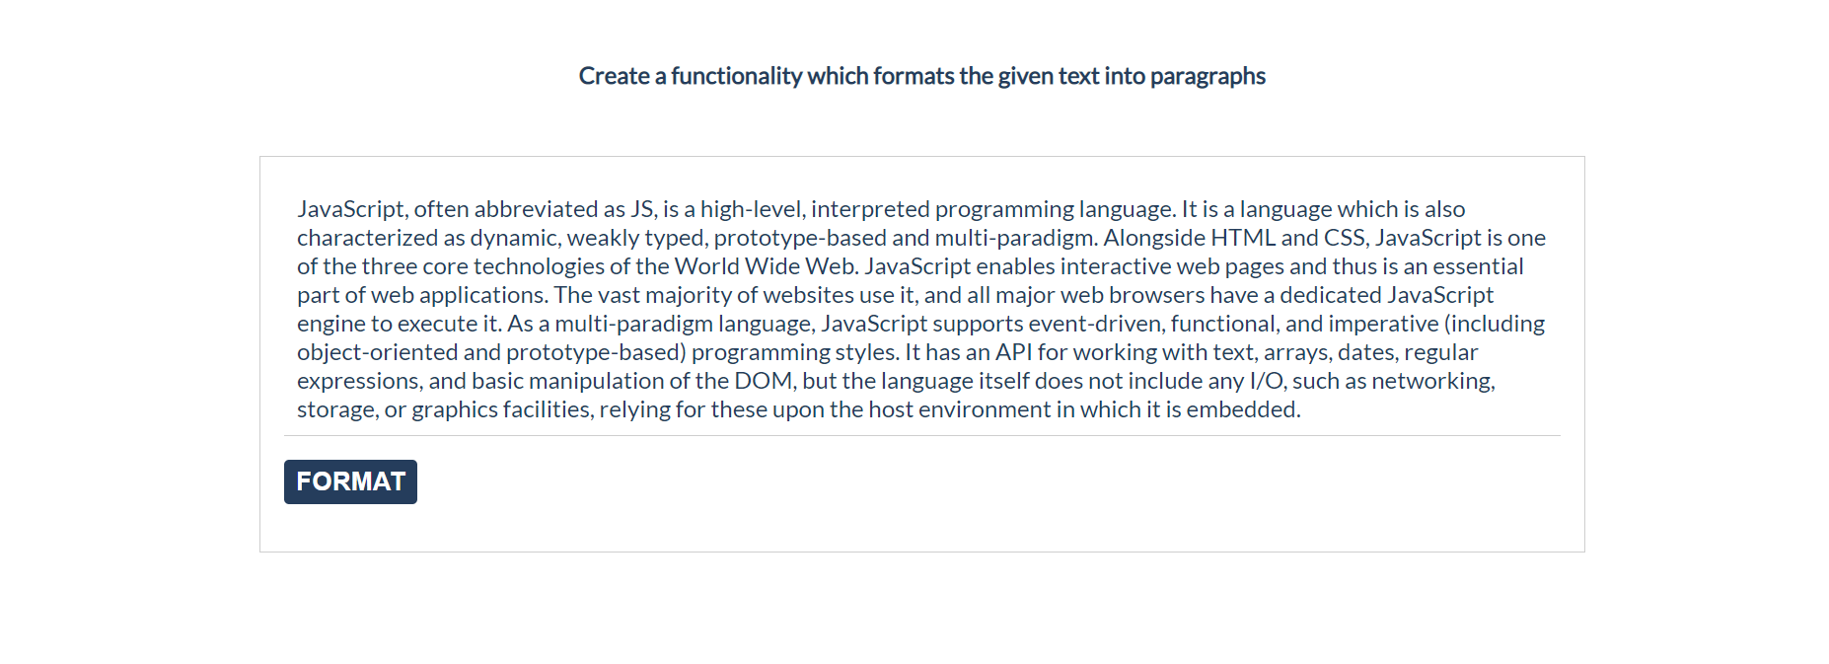

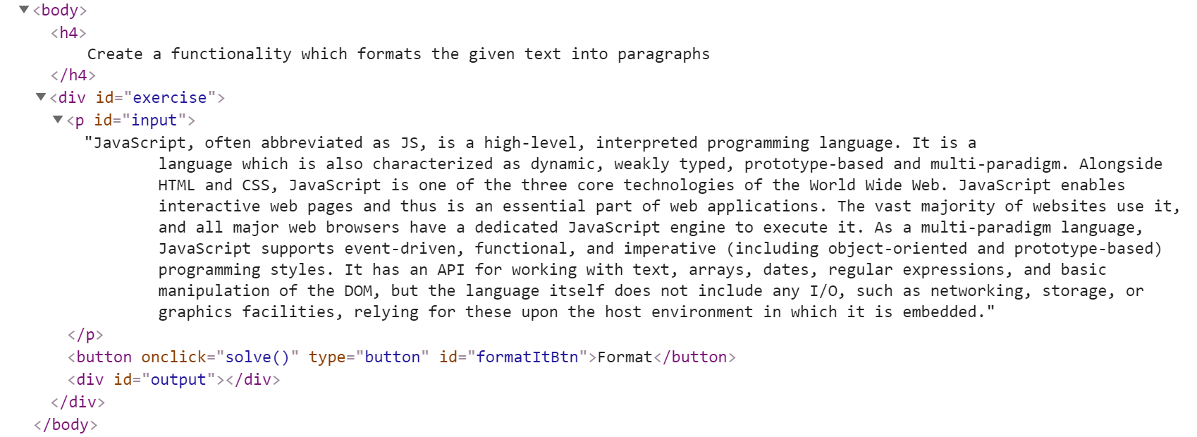

When the [**Format**] button is **clicked**, you need to **format the text** **inside** the **paragraph** with an **id** "**input**". The formatting is **done** as **follows:**

* You need to **create a new paragraph element which holds no more than 3 sentences from the given input.**
* If the given input contains **less** or **3 sentences**, you need to create only 1 paragraph, fill it with these sentences and append this paragraph to the div with an **id** "**output**".

Otherwise, when you have more than 3 sentences in that **input paragraph,** you need to create enough paragraphs to get all sentences from the **input text.**

Just remember to **restrict** the **sentences** in **each paragraph to 3.**

### Example:

* If the input paragraph **contains 2 sentences**, you need to create only **1 paragraph** with these 2 sentences
* If the input paragraph **contains 7 sentences,** you need to create **3 paragraphs**  
  - The **first paragraph** must contain **the first 3 sentences**  
  - The **second paragraph** must contain **the other three sentences of the whole text**  
  - The **third paragraph** will contain **only the last sentence**, because there are no more sentences in this paragraph

**To find out how many sentences there are in the text, simply split the whole text by '.' Also, every sentence must have at least 1 character.**

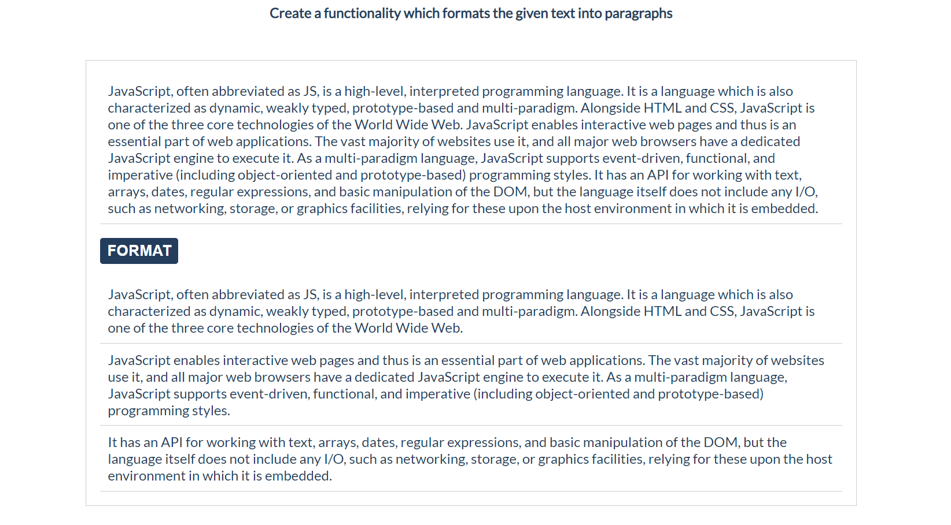

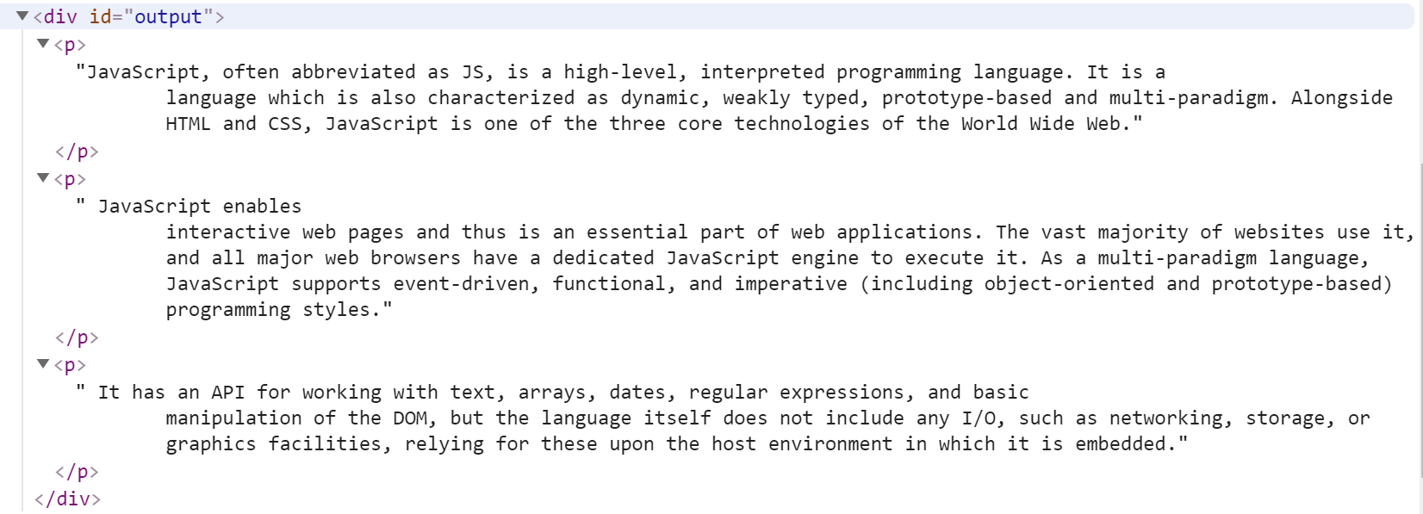

## Growing Word

In this problem, you should **create a JS functionality** which **changes the size and the color** of a given **paragraph** on **every click**.

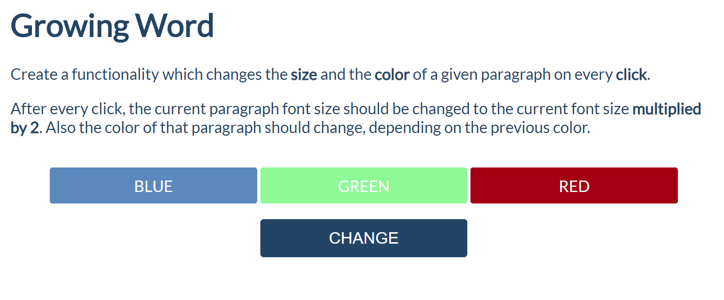

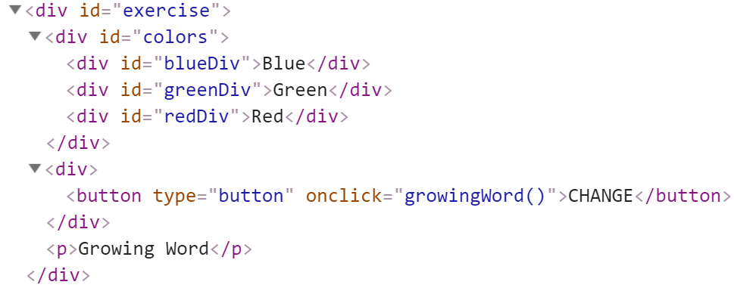

Every time when we **click** on the [**CHANGE**] button, **the color** and **the size** of **the paragraph** which contains "**Growing Word**" **should change!**

**After every click,** the current paragraph ***font size*** should be **changed** to the **current font size multiplied by 2.** Also, **the color** of that paragraph should change, depending on the **previous color**.

### Example:

* If we click **once**, the color should be changed to **blue** and the font size should be **2** (First initial size)
* If we click **twice,** the color should be changed to **green** and the font size should be **4** (2 * 2)
* If we click **three times**, the current color of that paragraph should be changed to **red** and the font size should be **8** (4 * 2)
* If our paragraph already has a **red color, on** the **next** click, the color should turn to **blue**. Just loop throw these three colors (blue, green, red) again and again and again... while you are clicking on that button.

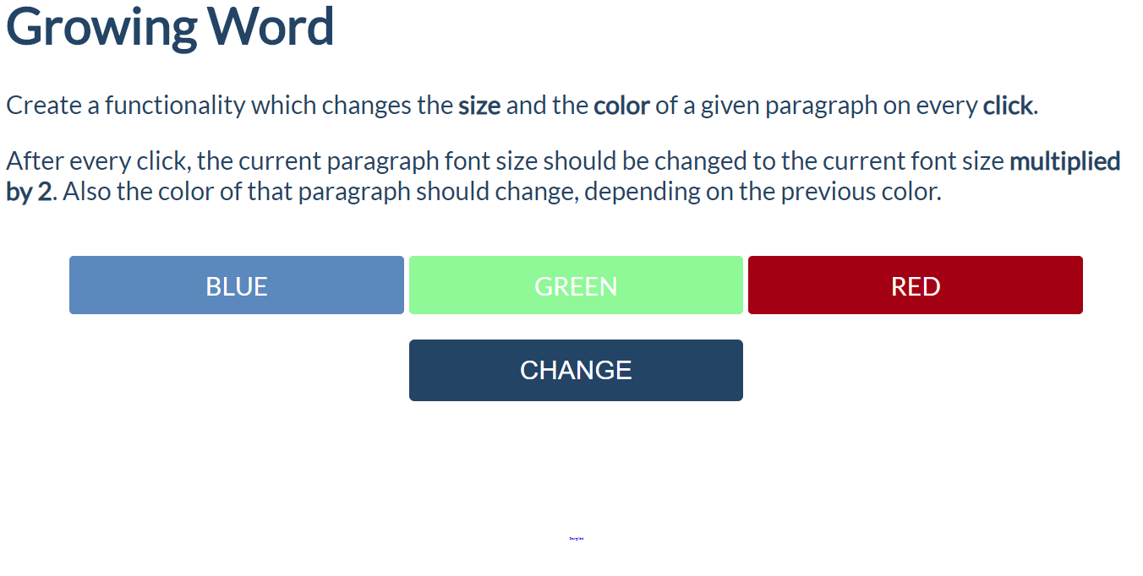

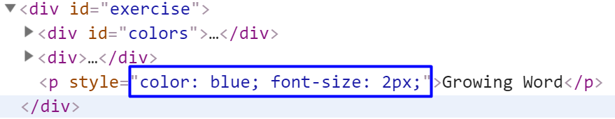

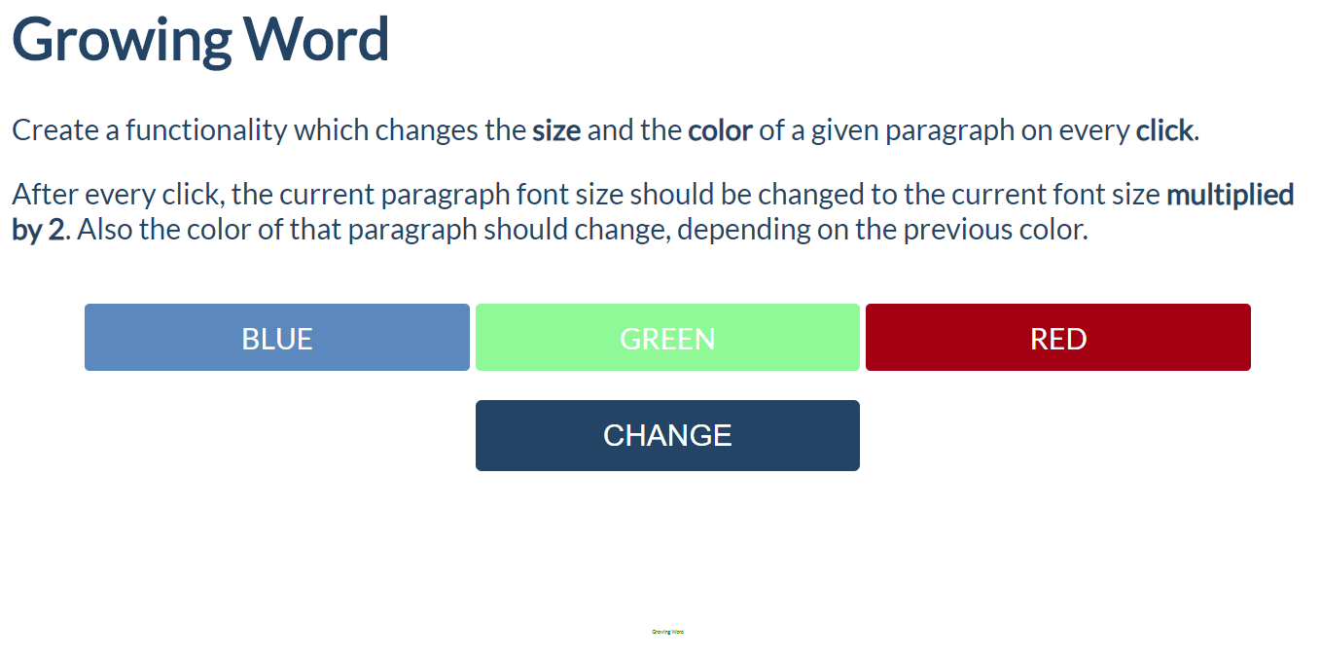

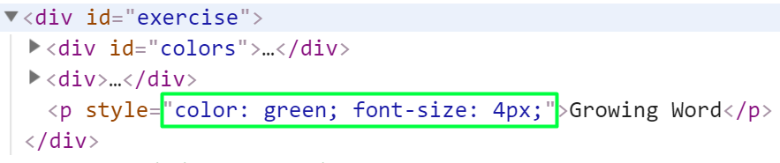

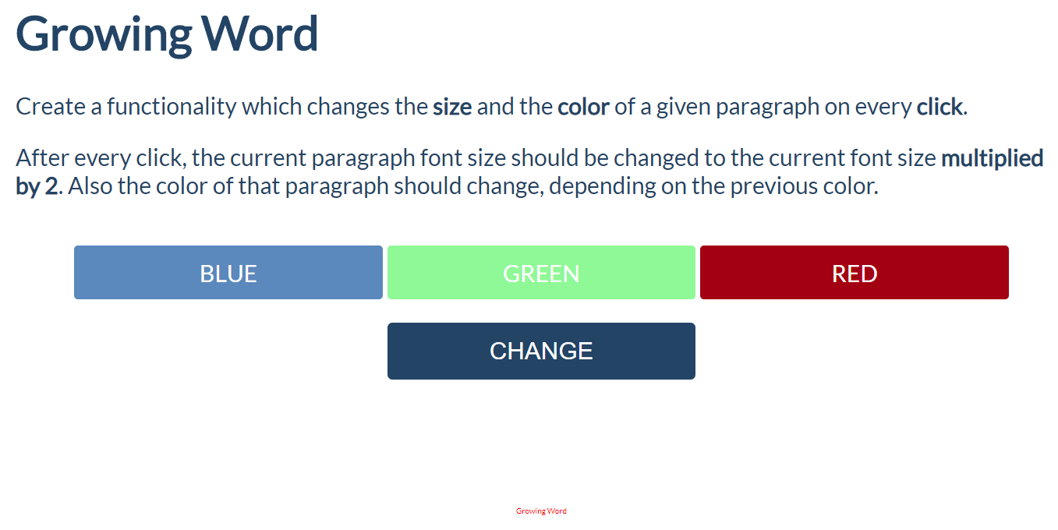

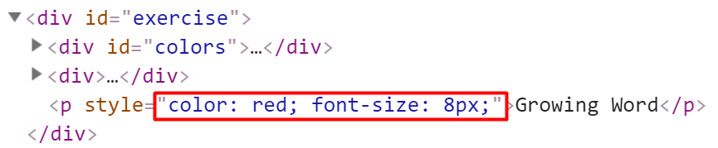

## Visited Sites

In this problem, you should **create a JS functionality** that keeps track of how many times a

specific site has been **visited**.



For instance, if we click **twice on the Gmail link and once on the YouTube link**, the expected

result must be:

